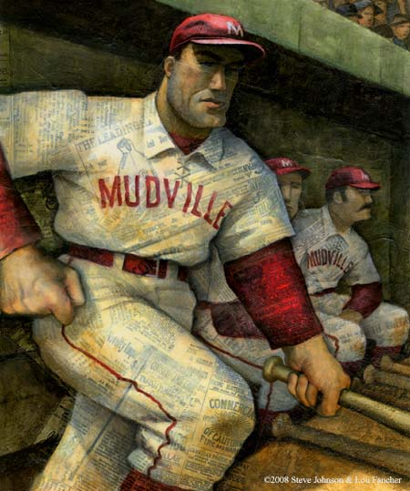
Casey at the Bat

The outlook wasn't brilliant for the Mudville nine that day;
The score stood four to two, with but one inning more to play,
And then when Cooney died at first, and Barrows did the same,
A pall-like silence fell upon the patrons of the game.

A straggling few got up to go in deep despair. The rest
Clung to that hope which springs eternal in the human breast;
They thought, "If only Casey could but get a whack at that —
We'd put up even money now, with Casey at the bat."

But Flynn preceded Casey, as did also Jimmy Blake,
And the former was a hoodoo, while the latter was a cake;
So upon that stricken multitude grim melancholy sat;
For there seemed but little chance of Casey getting to the bat.

But Flynn let drive a single, to the wonderment of all,
And Blake, the much despised, tore the cover off the ball;
And when the dust had lifted, and men saw what had occurred,
There was Jimmy safe at second and Flynn a-hugging third.

Then from five thousand throats and more there rose a lusty yell;
It rumbled through the valley, it rattled in the dell;
It pounded on the mountain and recoiled upon the flat,
For Casey, mighty Casey, was advancing to the bat.

There was ease in Casey's manner as he stepped into his place;
There was pride in Casey's bearing and a smile lit Casey's face.
And when, responding to the cheers, he lightly doffed his hat,
No stranger in the crowd could doubt 'twas Casey at the bat.

Ten thousand eyes were on him as he rubbed his hands with dirt.
Five thousand tongues applauded when he wiped them on his shirt.
Then while the writhing pitcher ground the ball into his hip,
Defiance flashed in Casey's eye, a sneer curled Casey's lip.

And now the leather-covered sphere came hurtling through the air,
And Casey stood a-watching it in haughty grandeur there.
Close by the sturdy batsman the ball unheeded sped —
"That ain't my style," said Casey. "Strike one!" the umpire said.

From the benches, black with people, there went up a muffled roar,
Like the beating of the storm-waves on a stern and distant shore;
"Kill him! Kill the umpire!" shouted someone on the stand;
And it's likely they'd have killed him had not Casey raised his hand.

With a smile of Christian charity great Casey's visage shone;
He stilled the rising tumult; he bade the game go on;
He signaled to the pitcher, and once more the dun sphere flew;
But Casey still ignored it, and the umpire said "Strike two!"

"Fraud!" cried the maddened thousands, and echo answered "Fraud!"
But one scornful look from Casey and the audience was awed.
They saw his face grow stern and cold, they saw his muscles strain,
And they knew that Casey wouldn't let that ball go by again.

The sneer has fled from Casey's lip, the teeth are clenched in hate;
He pounds with cruel violence his bat upon the plate.
And now the pitcher holds the ball, and now he lets it go,
And now the air is shattered by the force of Casey's blow.

Oh, somewhere in this favored land the sun is shining bright,
The band is playing somewhere, and somewhere hearts are light,
And somewhere men are laughing, and little children shout;
But there is no joy in Mudville — mighty Casey has struck out.
“Casey at the Bat” Terms: Give examples of each of these poetic devices within this poem.
- Alliteration: repetition of consonant sounds at the beginning of a group of words__________________________________________________________
- Metaphor: a comparison (NOT using like or as) of two unlike things
_______________________________________________________________
- Simile: a comparison using like or as
_______________________________________________________________
- Onomatopoeia: using words that sound like what they mean
_______________________________________________________________
- Hyperbole: exaggeration
______________________________________________________
- Personification: giving non-human things human characteristics
_______________________________________________________________
- Imagery: use of pictures or images that appeal to your senses
______________________________________________________
Step Up To The Plate: Create your own poetic devices.
- Metaphors:
  - Casey was________________________________________
  - The game was_____________________________________
- Similes:
  - Casey was like_____________________________________
  - The game was like__________________________________
- Onomatopoeia:
  - The bat___________________________________________
  - The crowd_________________________________________

Just For Fun: Can you Seuss? Finish these Seussisms if you can.
- “Why fit in when you were born to_____________________________”
- “The more that you read the more things you will know. The more you learn, the more______________________________.”
- “You have brains in your head. You have feet in your shoes. You can steer yourself any____________________________________.”
- “Sometimes the questions are complicated and the answers ____________________.”
- “Don’t cry because it’s over. Smile because it______________________.”
- “Today you are you, that is truer than true. There is no one alive who is ______________________________________________.”
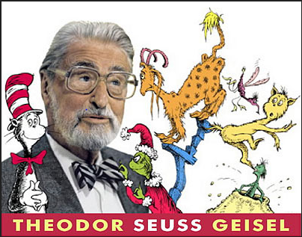
- “Be who you are and say what you feel, because those who mind don’t matter and those who ______________________________________.”

