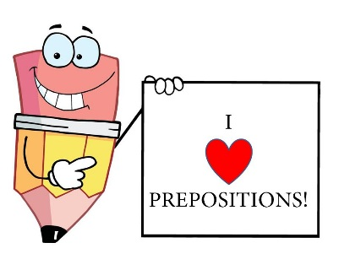
Name:____________________________________
Hour:___________

Chapter 6: Prepositions

Definition:
- Show _____________________________
- Have a ____________ or a ______________________ as their object

Prepositions communicate . . .
- Direction (Examples:_____________________________________________________)
- Time/Duration (Examples:_________________________________________________)
- Means (Examples:________________________________________________________)
- Cause (Examples: _________________________________________________________)
- Association (Examples:_____________________________________________________)
- Opposition/Exception (Examples:_____________________________________________)

Prepositions act like adjectives and adverbs in a sentence.

Adjective Questions Adverb Questions
W_____________________ H_____________
W_____________________ W_____________
H______________________ W_____________
H______________________ W_____________
W_____________________ T_______________________________

Troublesome Prepositions:

Between=_______________________________ Among=______________________________________
In=_____________________________________ Into=________________________________________
Beside=_________________________________ Besides=_____________________________________

Adverb or Preposition? What is the difference?

Adverb:__________________________________________________________
Preposition:_______________________________________________________

Avoid Misplaced Prepositional Phrases!
Fix these!
- The boy drove the convertible with the German shepherd.
______________________________________________________________________________

- Without his collar on, Shane had a hard time catching Shadow.
______________________________________________________________________________

