**Name:\_\_\_\_\_\_\_\_\_\_\_\_\_\_\_\_\_\_\_**

**Hour:\_\_\_\_\_**

**Sonnet 116**

Let me not to the marriage of true minds

Admit impediments; love is not love

Which alters when it alteration finds,

Or bends with the remover to remove.

O no, it is an ever-fixed mark,

That looks on tempests and is never shaken;

It is the star to every wand’ring bark,

Whose worth’s unknown, although his height be taken.

Love’s not Time’s fool, though rosy lips and cheeks

4n__gqv2[1] Within his bending sickle’s compass come;

Love alters not with brief hours and weeks,

But bears it out even to the edge of doom.

If this be error and upon me proved,

I never writ, nor no man ever loved.

William Shakespeare

**Practice Section:**

L m n t t m o t m

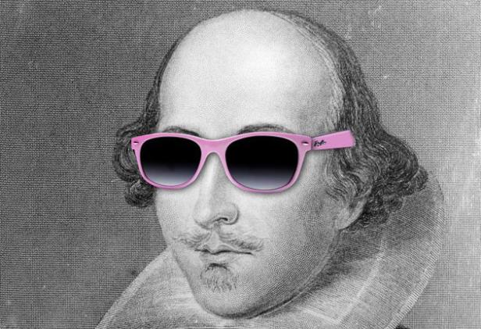A i; l i n l

W a w i a f,

O b w t r t r.

O n, i i a e-f m,

T l o t a i n s;

I i t s t e w b,

W w u, a h h b t.

L n T f, t r l a c

W h b s c c;

L a n w b h a w,

B b i o e t t e o d.

I t b e a u m p,

I n w, n n m e l.